EC-341 Digital System Design
BS(CE)-2021
LAB REPORT # 05

Submitted By:
Reg. No. | Name
21-CE-009 | Huzaifa Shahbaz
21-CE-021 | Yawar Ali Malik
21-CE-020 | Muhammad Ibthesam Khan

Department of Computer Engineering
BS Computer Engineering Program
HITEC University Taxila
 | Presentation  (Format(0.5)+ Title (0.5)+  Conclusion(1)  +Procedure(2)  +Objective(1)) | Calculation/ Coding | Observation/  Program Results | Total
Total | 5 | 5 | 5 | 15
Obtained

___________________________
Lab Instructor.
Engr. Fasih Ahmad

Experiment # 05
Implementation of Combinational Circuits
Objective
- Combinational circuits
- The Adder
- Lab tasks

Software Used
- Vivado
Procedure
We begin by creating Verilog modules using behavioral modeling for the half adder, full adder, 2-bit adder, and 2-bit 2's complement adder. Define inputs and outputs for each module and connect switches for inputs and LEDs for outputs on the FPGA board. Extend the Verilog modules as necessary, incorporating additional logic for carry inputs and overflow conditions. Synthesize the designs and program the FPGA, ensuring proper pin assignments. Test the functionality of each circuit by toggling input switches and observing the corresponding LED outputs, verifying correct computation of sums and carries, as well as handling of negative numbers and overflow conditions in the 2's complement adder. Document the results and any observations in the report for clarity and reference.

Tasks
Constraint file:
NOTE: This is used the same in all codes below,
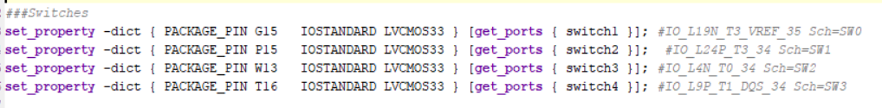
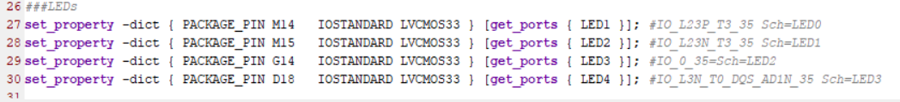
Task 1:
Block Diagram:
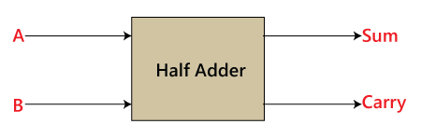
Circuit:
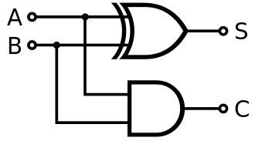
Logism Implementation:
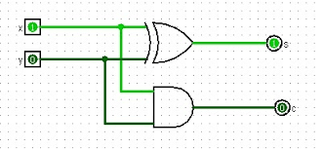
Truth Table:
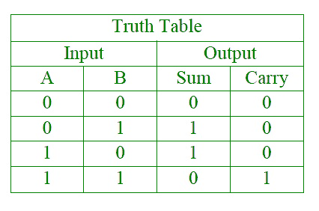

Code:
module Hadd(input switch1,input switch2,output reg LED1,output reg LED2);
always@(switch1 or switch2)
begin
LED1=switch1^switch2;
LED2=switch1&switch2;
end
endmodule
Output:
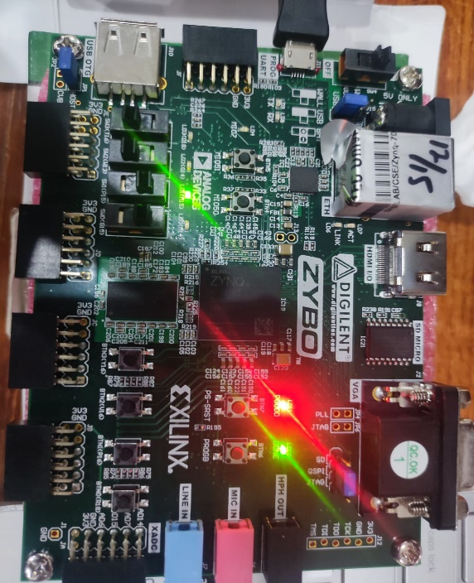

Task 2
Block Diagram:
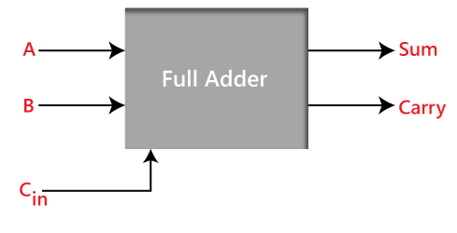

Circuit:
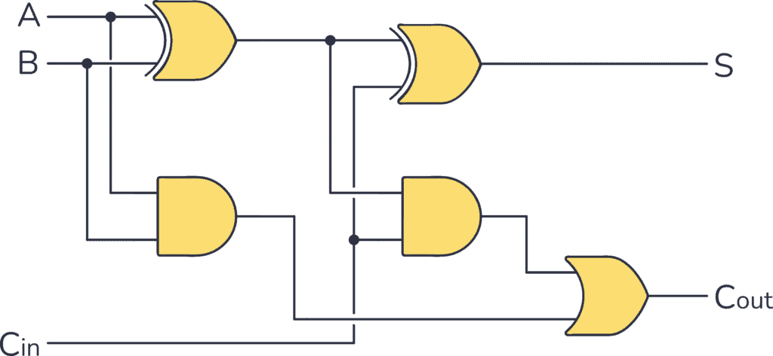
Logism Implementation:
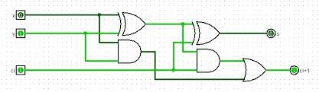
Truth Table:
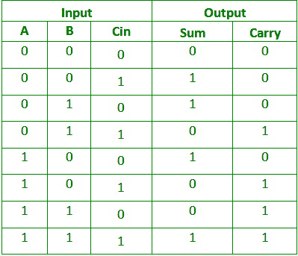
Code:
module Fudd(
input switch1,
input switch2,
input switch3,
output reg LED1,
output reg LED2
);
always@(switch1 or switch2 or switch3)
begin
LED1=switch1^switch2^switch3;
LED2=switch3&(switch1^switch2)|(switch1&switch2);
end
endmodule
Output:
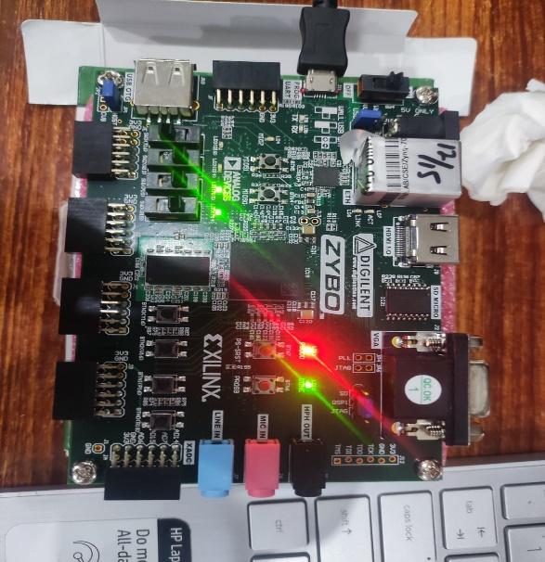
Task 3
Block Diagram:
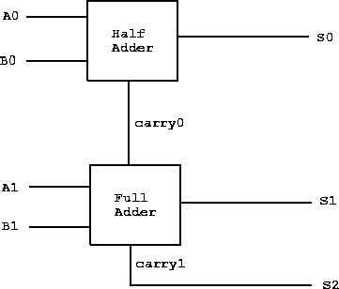
Circuit:
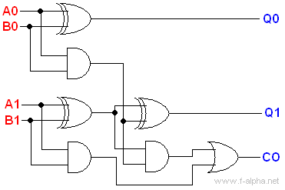
Logism Implementation:
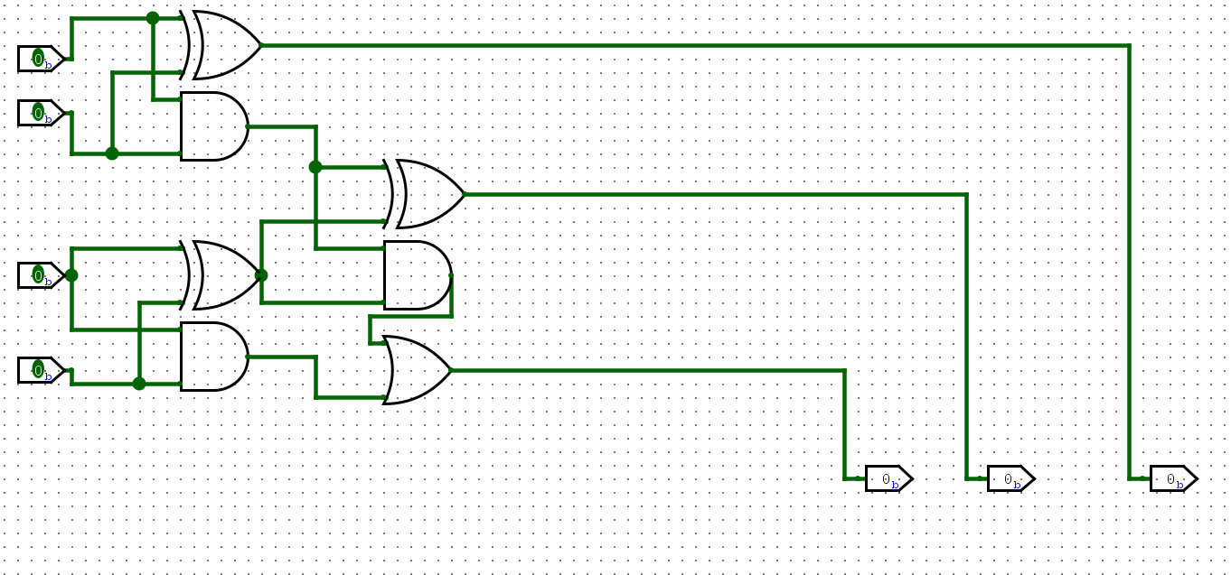
Truth Table:
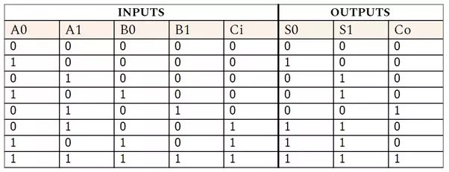
Code:
module tadd(
input switch1,
input switch2,
input switch3,
input switch4,
output reg LED1,
output reg LED2,
output reg LED3,
output reg LED4
);
always@(switch1 or switch2 or switch3 or switch4)
begin
LED1=switch1^switch2;
LED2=switch1&switch2;
LED3=switch3^switch4^LED2;
LED4=LED2&(switch3^switch4)|(switch3&switch4);
end
endmodule
Output:
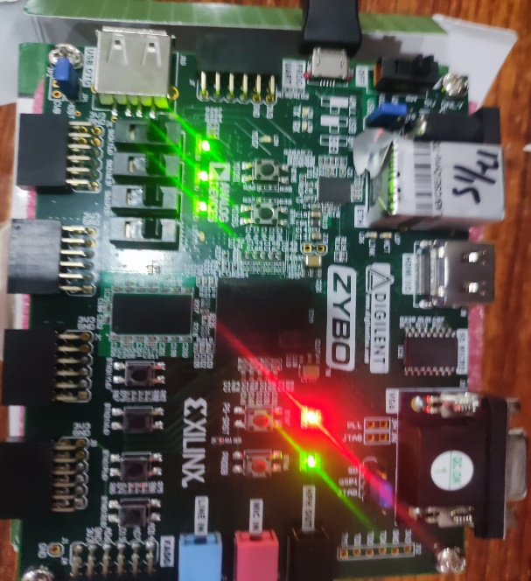
Task 4
module code (
input [1:0] switch1,
output reg [1:0] LED1
);
always @(*) begin
if (switch1 == 2'b11)
LED1 = 2'b00;
else
LED1 = (~switch1) + 2'b01;
end
endmodule

Output:
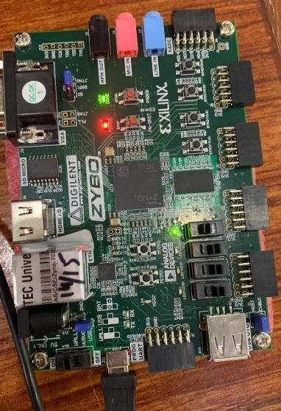

Conclusion
In this lab, we successfully implemented various combinational circuits, including the half adder, full adder, 2-bit adder, and 2-bit 2's complement adder. Utilizing switches and LEDs as input and output interfaces respectively, we demonstrated the functionality of these circuits on an FPGA platform. Through this hands-on exercise, we gained valuable insights into digital system design.

